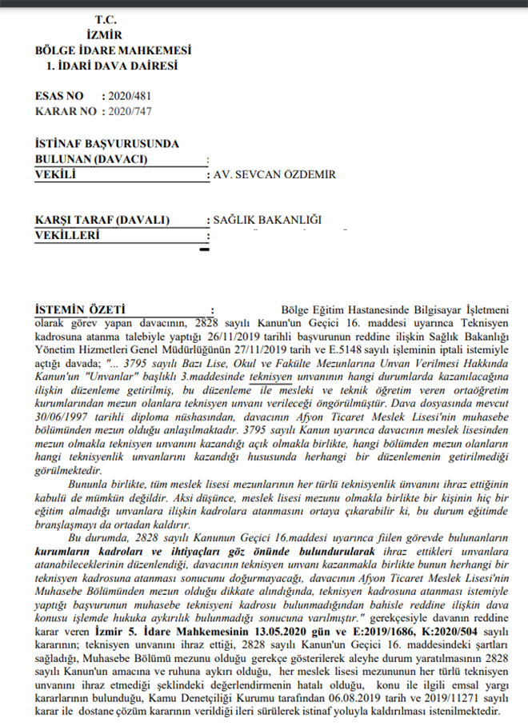[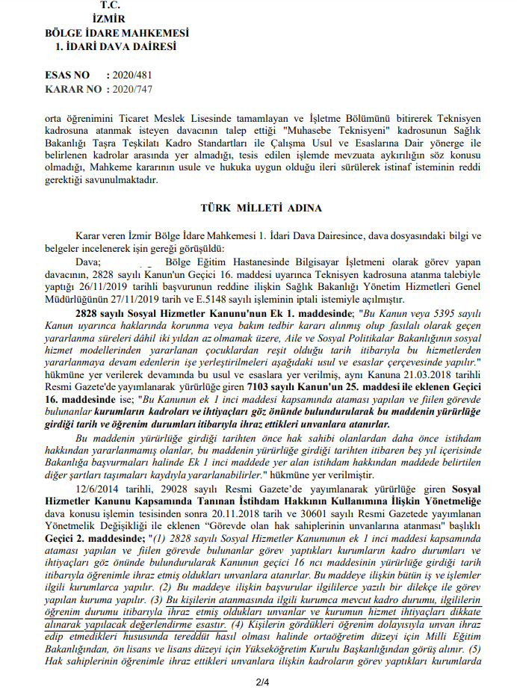](https://www.memurlar.net/common/news/documents/944402/cigli2.jpg)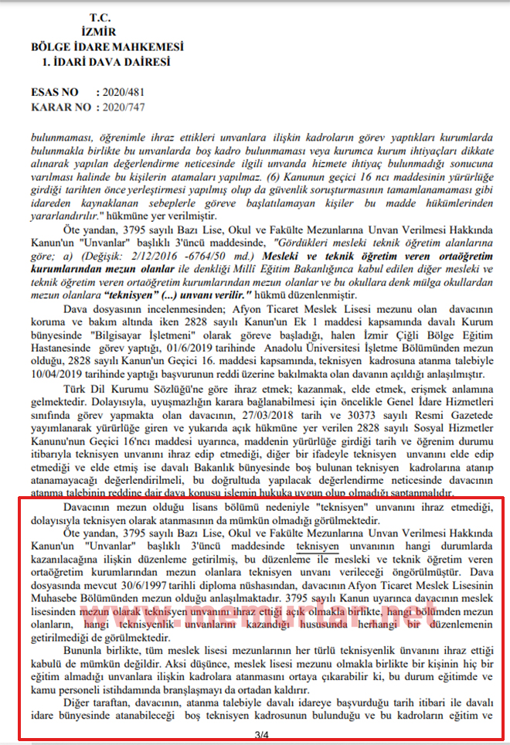[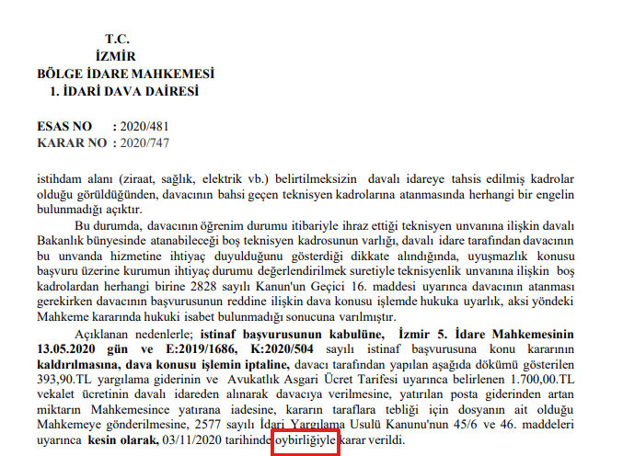](https://www.memurlar.net/common/news/documents/944402/cigli4.jpg)